***Supporting Information***

***for***

**Characteristics of phages and their interactions with hosts in anaerobic reactors**

Yan Zenga,b, Xiaozhong Zhongc, Yating Chenb,d, Min Goub,e, Ke Yuf, Yue-Qin Tanga,b,e,g*

a Institute of New Energy and Low-carbon Technology, Sichuan University, No. 24, South Section 1, First Ring Road, Chengdu, Sichuan, China

b Sichuan Environmental Protection Key Laboratory of Organic Wastes Valorization, Chengdu, Sichuan, China

c College of Life Sciences, Sichuan Agricultural University, Yaan, Sichuan, China

d Institute for Disaster Management and Reconstruction, Sichuan University, Chengdu, Sichuan, China

e College of Architecture and Environment, Sichuan University, No. 24, South Section 1, First Ring Road, Chengdu, Sichuan, China

f Eco-environment and Resource Efficiency Research Laboratory, School of Environment and Energy, Shenzhen Graduate School, Peking University, Shenzhen, China.

g Engineering Research Centre of Alternative Energy Materials and Devices, Ministry of Education, Chengdu, Sichuan, China

*Correspondence: Yue-Qin Tang

Tel. (fax): +86 28 85990936

E-mail address:

Yan Zeng: zengyan.zy@foxmail.com

Xiaozhong Zhong: xiaozhong@sicau.edu.cn

Yating Chen: cytscu1101@scu.edu.cn

Min Gou: goumin@scu.edu.cn

Ke Yu: yuke.sz@pku.edu.cn

Yue-Qin Tang: [tangyq@scu.edu.cn](mailto:tangyq@scu.edu.cn)

The following are included as supporting information for this paper:

Number of pages: 8

Number of figures: 4

Number of tables: 8

**Supplementary figures**

-**Fig. S1.** A gene-sharing network of phages from AD reactors and NCBI Viral RefSeq database. In this network, nodes represent phages, and edges represent similarity.

-**Fig. S2.** The metagenomics-based abundance (MG) and metatranscriptomics-based activity (MT) of shared vOTUs in mesophilic and thermophilic anaerobic digestion (AD) reactors.

**-Fig. S3.** Virus/host abundance (a) and activity (b) ratios (VHRs) in AD reactors.

-**Fig. S4.** Boxplot of the overall gene profile was summarized both as phage ORF hits (a) and phage ORF relative abundance (b) in different samples. Viral ORF relative abundance was calculated as ORF hits to each COG function class/total ORFs that have hits to eggNOG database.

**Supplementary tables**

**-Table S1.** Sequencing information for metagenomic and metatranscriptomic data used in this study.

**-Table S2.** Characteristics for 921 metagenome-assembled genomes (MAGs), including genome quality, assigned taxonomy, abundance, and activity.

**-Table S3.** Characteristics for 383 non-redundant metagenome-assembled genomes, including genome quality, assigned taxonomy, abundance, and activity.

**-Table S4.** Characteristics of 2121 vOTUs in this study.

**-Table S5.** Viral clusters based on shared genes (vConTACT2).

**-Table S6.** Characteristics of the putative virus-host linkages.

**-Table S7.** Details about selected AMGs based on DRAM-v.

**-Table S8.** Genomic context for selected AMGs used for Figure 7.

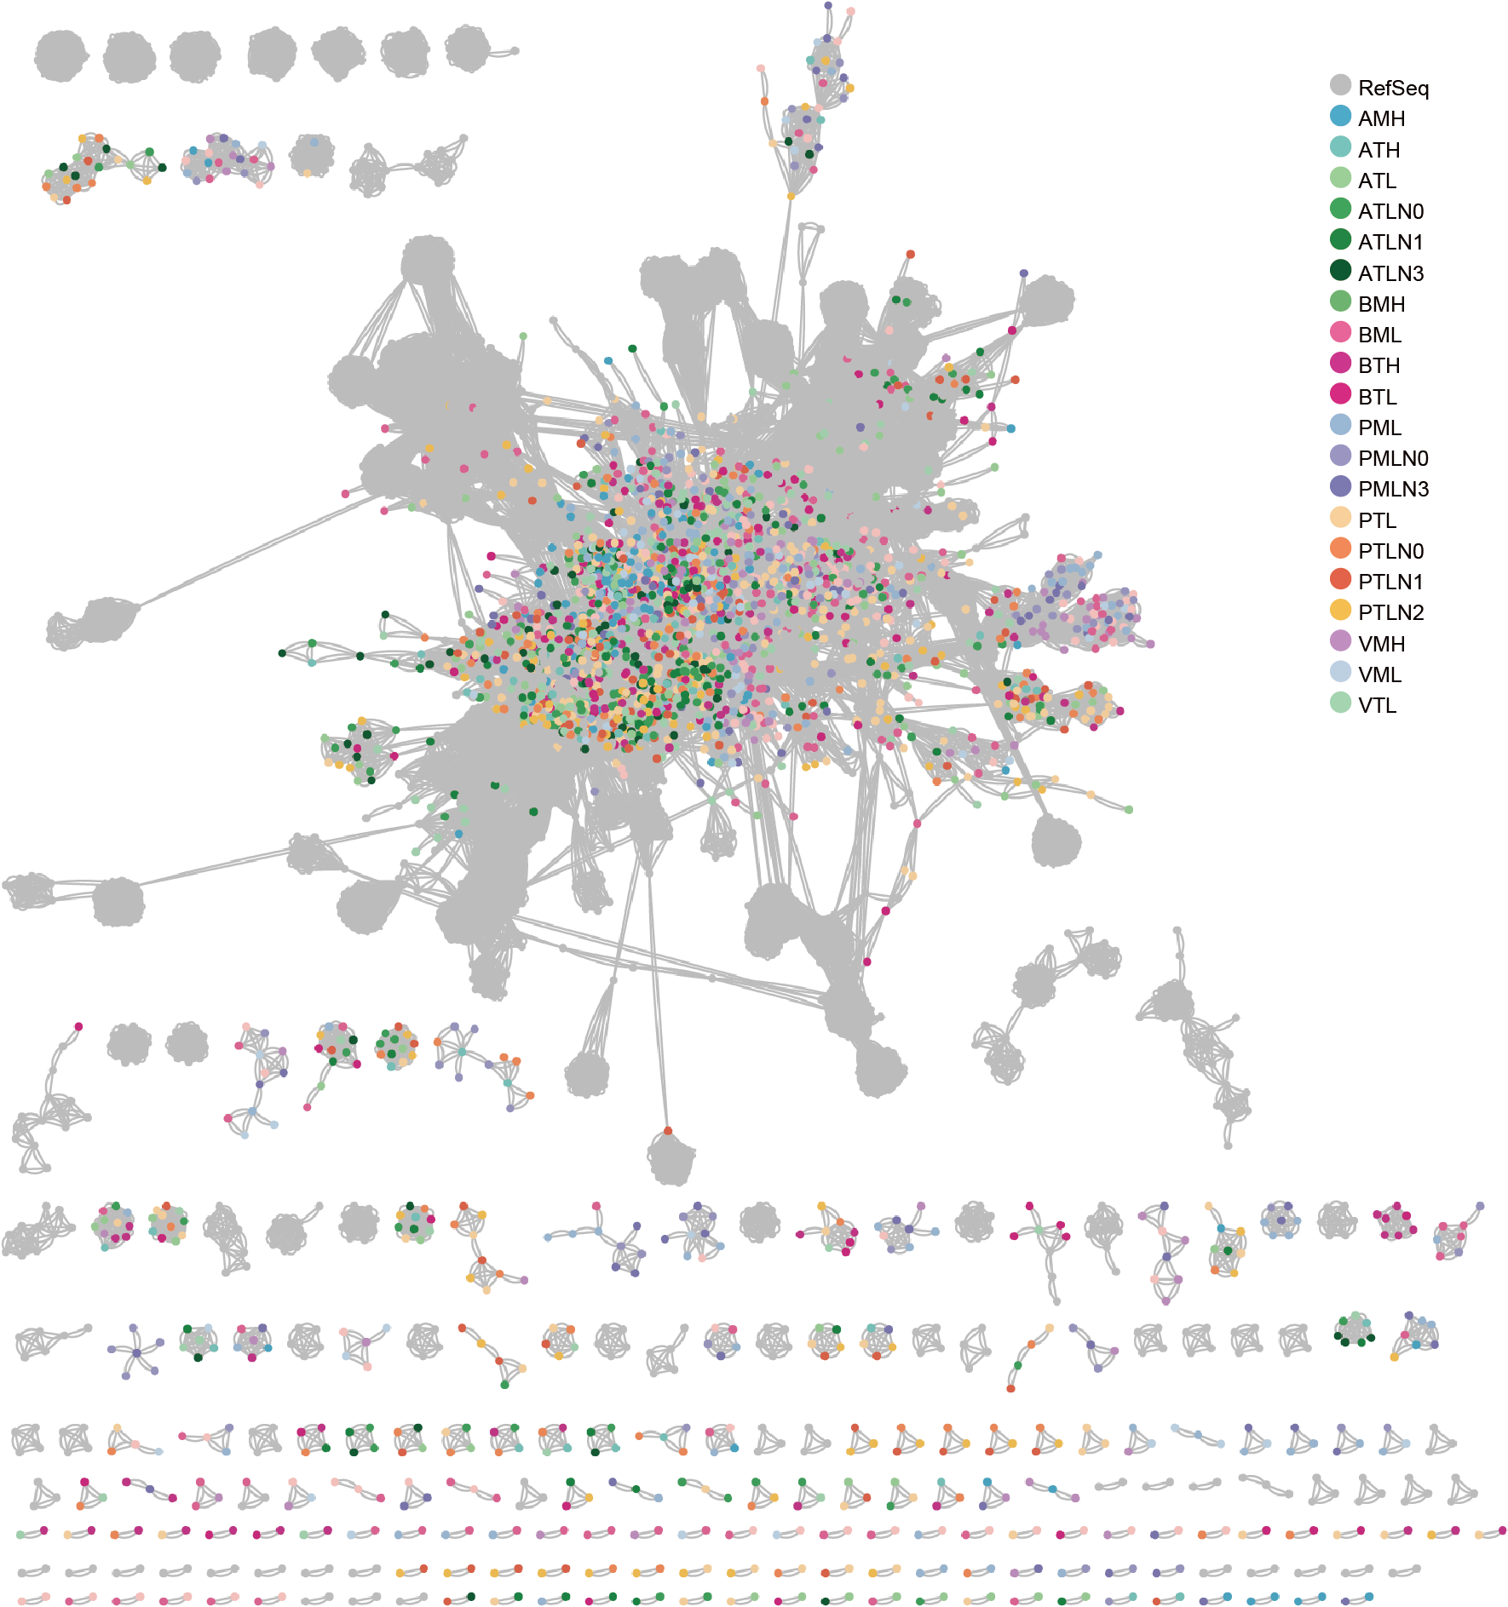

**Fig. S1.** A gene-sharing network of phages from AD reactors and NCBI Viral RefSeq database. In this network, nodes represent phages, and edges represent similarity.

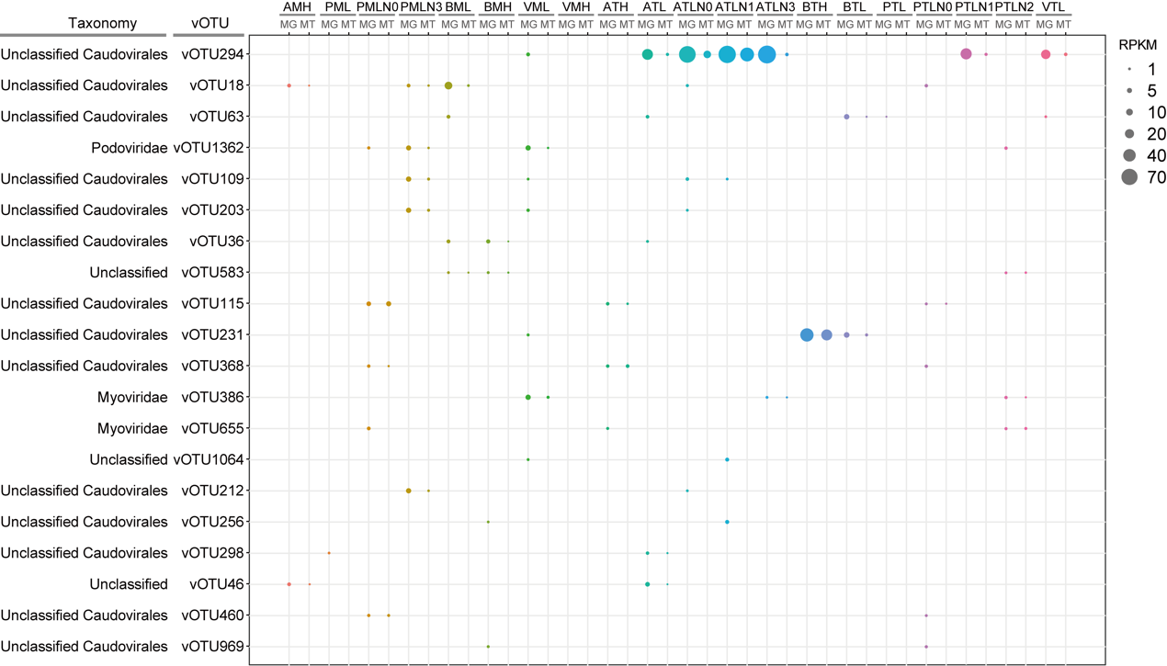

**Fig. S2.** The metagenomics-based abundance (MG) and metatranscriptomics-based activity (MT) of shared vOTUs in mesophilic and thermophilic anaerobic digestion (AD) reactors.

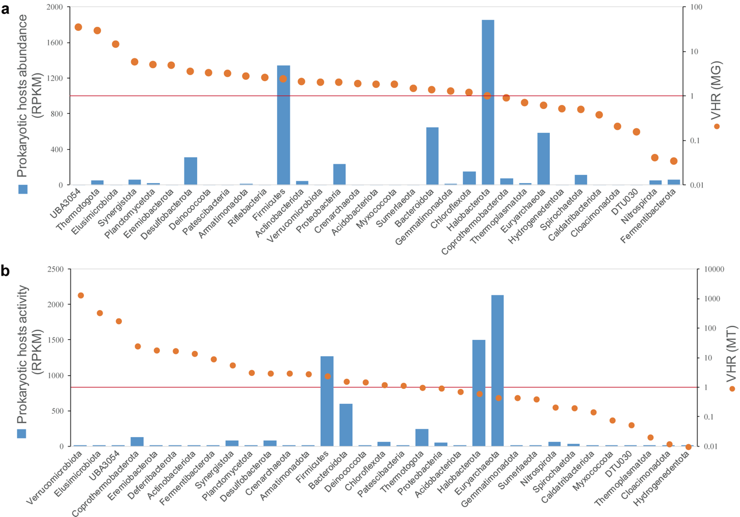

**Fig. S3.** Virus/host abundance (a) and activity (b) ratios (VHRs) in AD reactors.



**Fig. S4**. Boxplot of the overall gene profile was summarized both as phage ORF hits (a) and phage ORF relative abundance (b) in different samples. Viral ORF relative abundance was calculated as ORF hits to each COG function class/total ORFs that have hits to eggNOG database.